RabbitMQ Installation - Windows

We will see how to set up RabbitMQ in Windows OS. RabbitMQ is a powerful open-source message broker that enables applications to communicate with each other by sending and receiving messages. It is widely used for handling high throughput, distributed systems, and microservices architectures.
Prerequisites
Before starting the installation process, ensure you have the following:
- Windows Operating System: Windows 10 or later is recommended.
- Erlang: RabbitMQ is built on top of the Erlang programming language, so you’ll need to have the Erlang runtime installed. Check Erlang version compatibility with RabbitMQ
- Administrative privileges: You may need admin rights to install software on your machine.

Step 1: Install Erlang
RabbitMQ requires Erlang for its backend services. Follow these steps to install Erlang:
- Download Erlang:
  - Go to the official Erlang website: Erlang Downloads.
  - Select the Windows version (e.g., “Erlang/OTP 24.x.x”).
- Install Erlang:
  - Run the downloaded installer.
  - Follow the installation wizard and choose the default options, unless you have specific requirements.
  - Ensure that the installation path of Erlang is added to your system’s PATH environment variable.

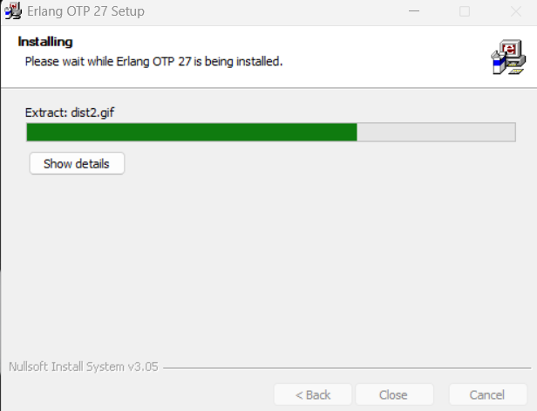

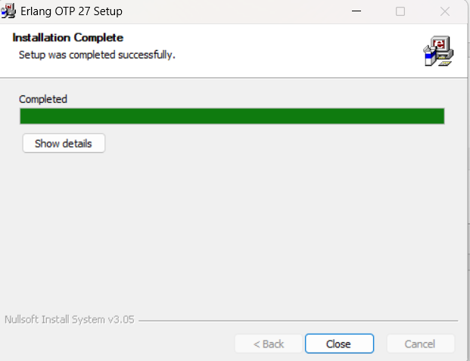

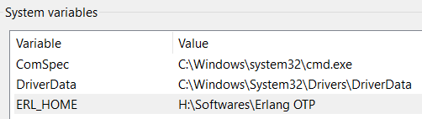
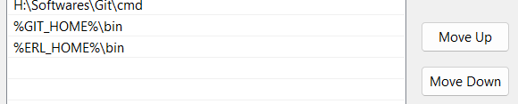

Verify Erlang Installation:
Open Command Prompt and run: erl
If Erlang is installed correctly, you should see the Erlang shell prompt (1>). Type halt(). to exit.
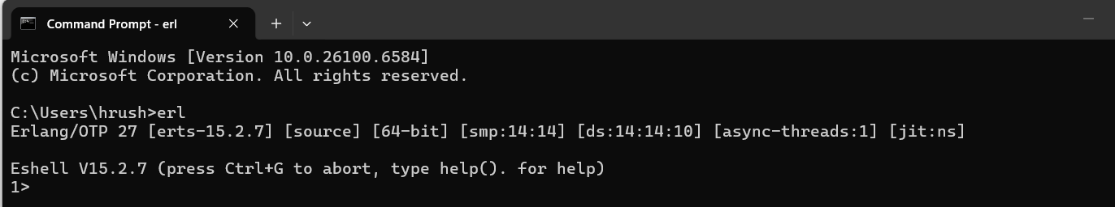

Step 2: Download RabbitMQ
Next, download the RabbitMQ server.
- Download RabbitMQ:
  - Go to the official RabbitMQ website: RabbitMQ Downloads.
https://github.com/rabbitmq/rabbitmq-server/releases/download/v4.1.5/rabbitmq-server-4.1.5.exe
  - Look for the latest RabbitMQ server version and download the .exe installer file.

Step 3: Install RabbitMQ
Once RabbitMQ is downloaded, you can proceed with the installation.
- Run the RabbitMQ Installer:
  - Double-click the downloaded RabbitMQ installer and follow the installation prompts.
  - It’s advisable to keep the default installation directory unless you have a reason to change it.
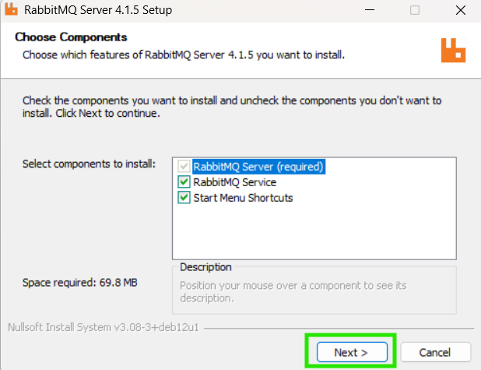
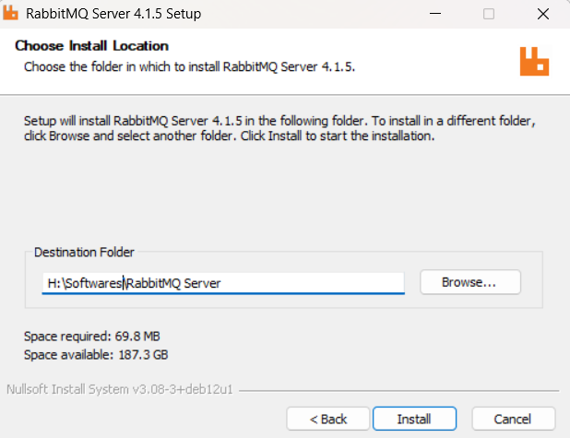
Allow all permissions and continue
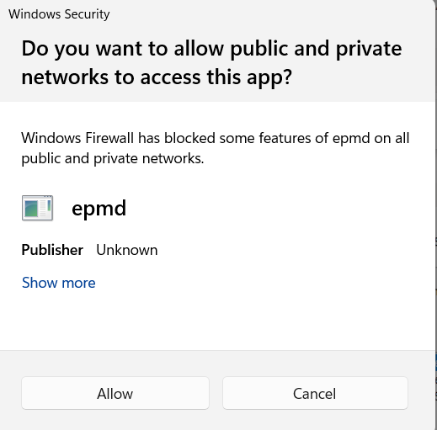
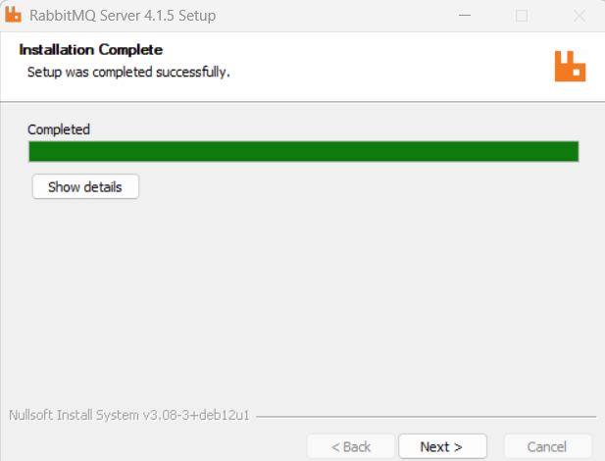
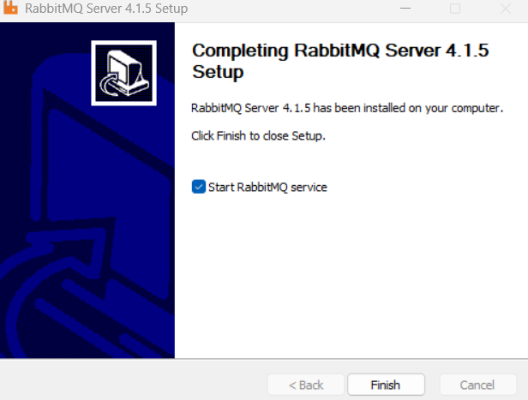

- Set Environment Variables:
  - After installation, add the RabbitMQ sbin directory to your system’s PATH variable. The typical path is:
C:\Program Files\RabbitMQ Server\rabbitmq_server-x.x.x\sbin

Step 4: Start RabbitMQ Server
After the installation, start the RabbitMQ server to make sure everything is set up correctly.
Open Command Prompt as Administrator.
Start RabbitMQ Server:
> rabbitmq-server
You should see logs indicating that RabbitMQ is starting up. Look for the line that says Server startup complete.
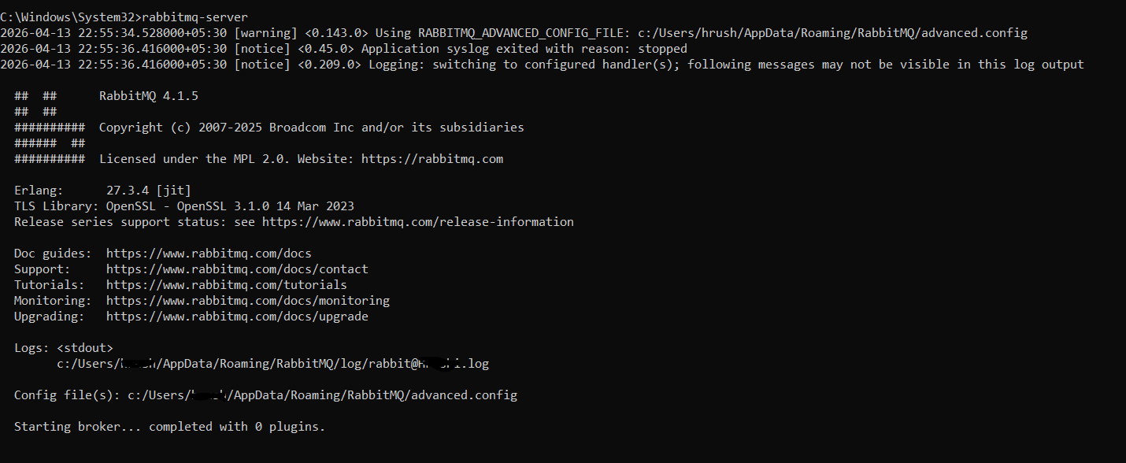

Enabling the RabbitMQ Management Plugin
To simplify management and monitoring, it’s recommended to enable the RabbitMQ management plugin.
Enable the Management Plugin:
> rabbitmq-plugins enable rabbitmq_management
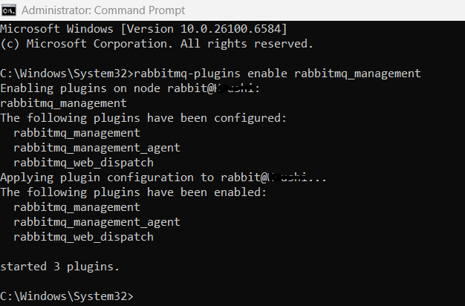

Access the Management Dashboard:
  - Open a web browser and navigate to:
http://localhost:15672/
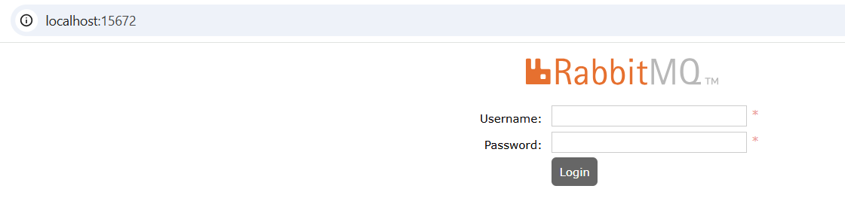
  - Log in with the default credentials:
    - Username: guest
    - Password: guest
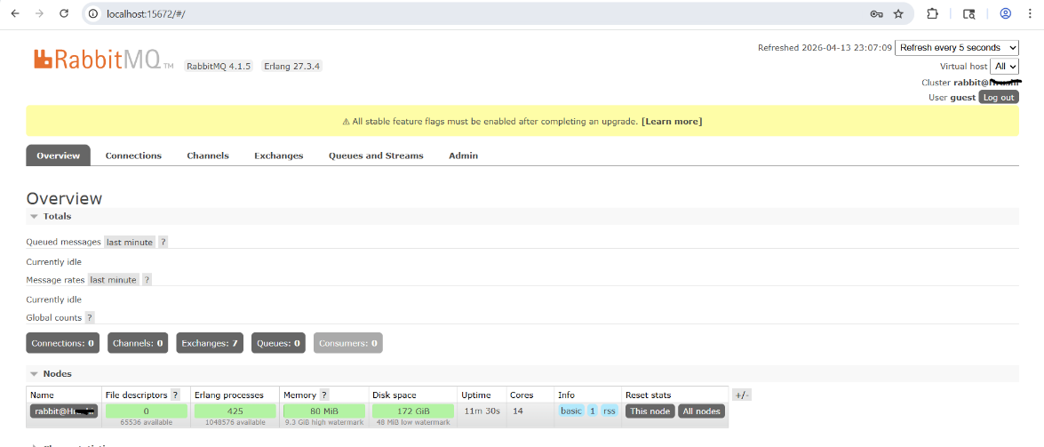

Step 5: Verify RabbitMQ Installation
- Check RabbitMQ Status:
Open a new Command Prompt (do not close the existing server window).
  - Run the command:
> rabbitmqctl status
You should see output detailing the RabbitMQ server status.
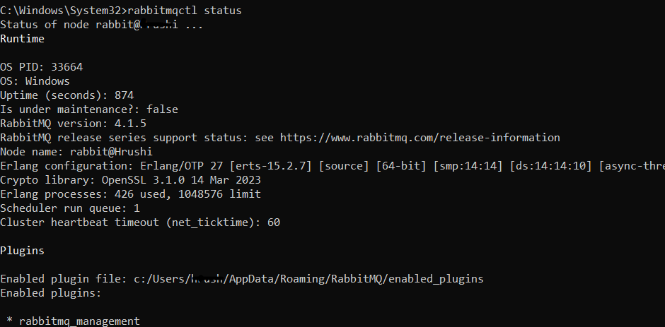
- Create a Sample Queue:
  - Access the management dashboard.
  - Go to the “Queues” tab and create a new queue (e.g., test_queue).
- Publish a Test Message:
  - Use the “Publish Message” feature in the management dashboard to send a test message to test_queue.
- Consume the Message:
  - Set up a simple consumer (using a programming language like Python, Java, etc.) to retrieve and confirm message delivery.

Congratulations, you have successfully installed RabbitMQ on your Windows machine. You now have a powerful messaging system at your disposal that you can integrate with various applications and services. By leveraging RabbitMQ, you can create scalable and efficient systems that enhance communication between different components of your applications.

Reference – (Installation Instructions for different OS)
- Linux, BSD, UNIX: Debian, Ubuntu | RHEL, CentOS Stream, Fedora | Generic binary build | Solaris
- Windows: Chocolatey package | Windows Installer | Binary build
- MacOS: Homebrew | Generic binary build

